HOW TO ACCESS OCCUPATIONAL THERAPY (OT), PHYSIOTHERAPY (PT) and SPEECH-LANGUAGE PATHOLOGY (SLP) DOCUMENTATION IN THE ELECTRONIC MEDICAL RECORD (EMR)
All OT, PT and SLP assessment and treatment documentation is located in the EMR. In order to keep all team members aware of patient’s care plans it is important that you know how to access this information. There are two ways you can access this information quickly.
OPTION 1

- Open the EMR and choose your patient.
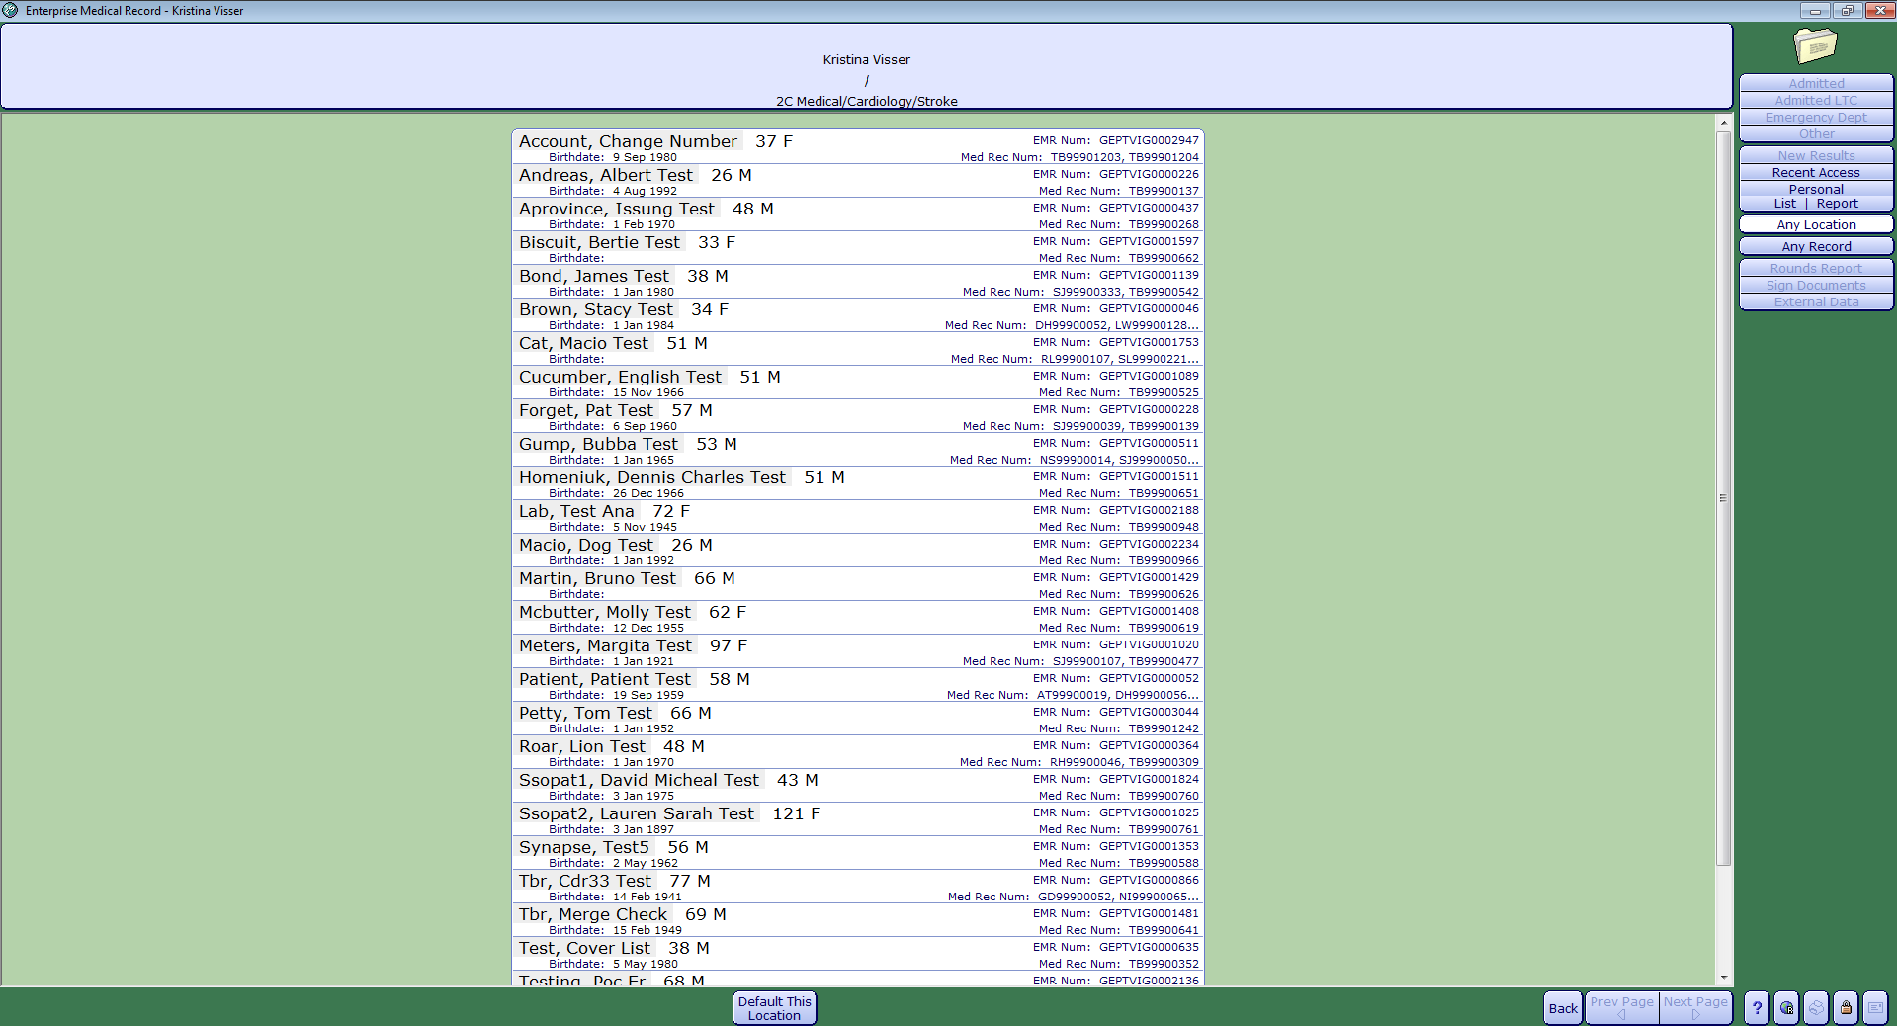

- Choose the current admission to access the notes/interventions for the admission, OR choose “view all visits” to see all interprofessional notes recorded in any admission.
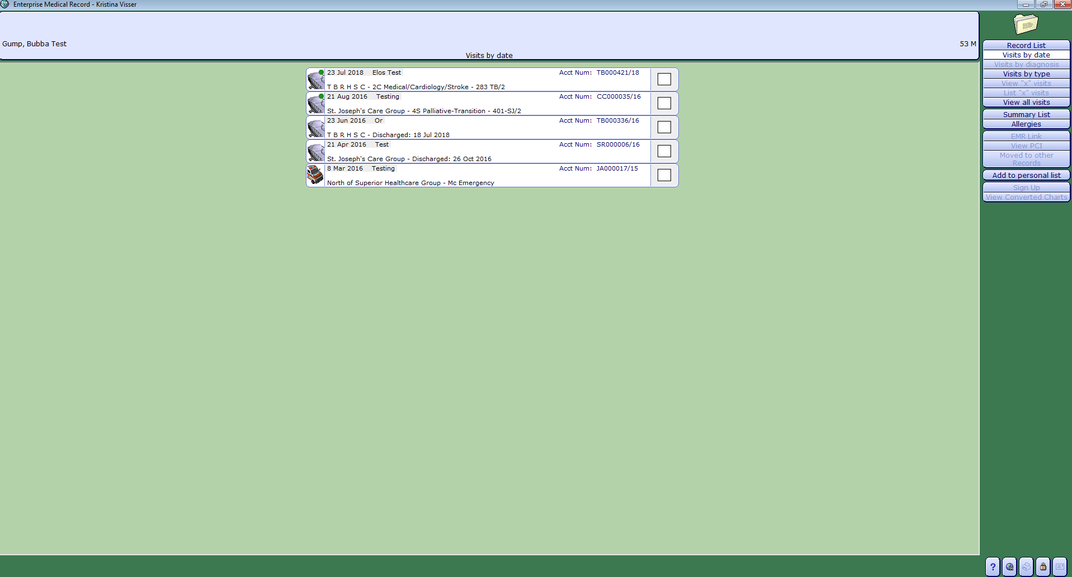
OR

- Choose the “Notes” tab in the menu on the right hand side of screen.
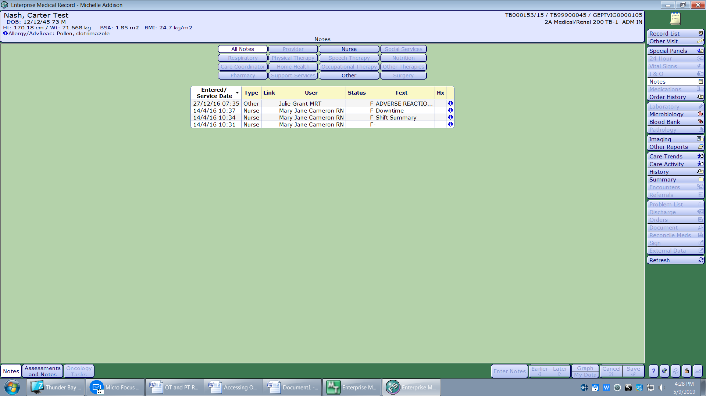

- At the bottom left of the screen click the “Assessments and Notes” tab.
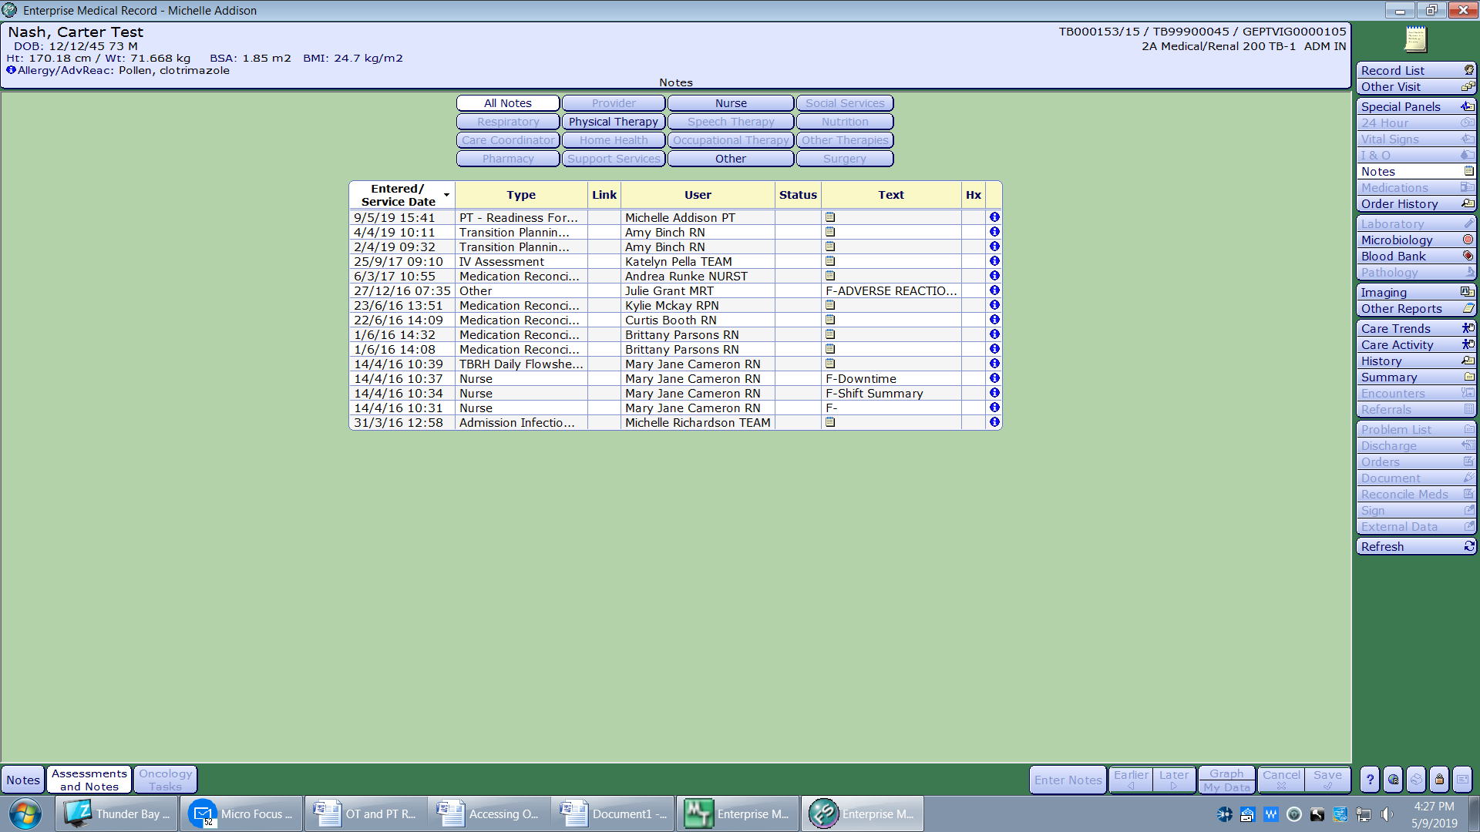

- You can view “All Notes” or filter your search by selecting a profession for the assessment/note you want to review.
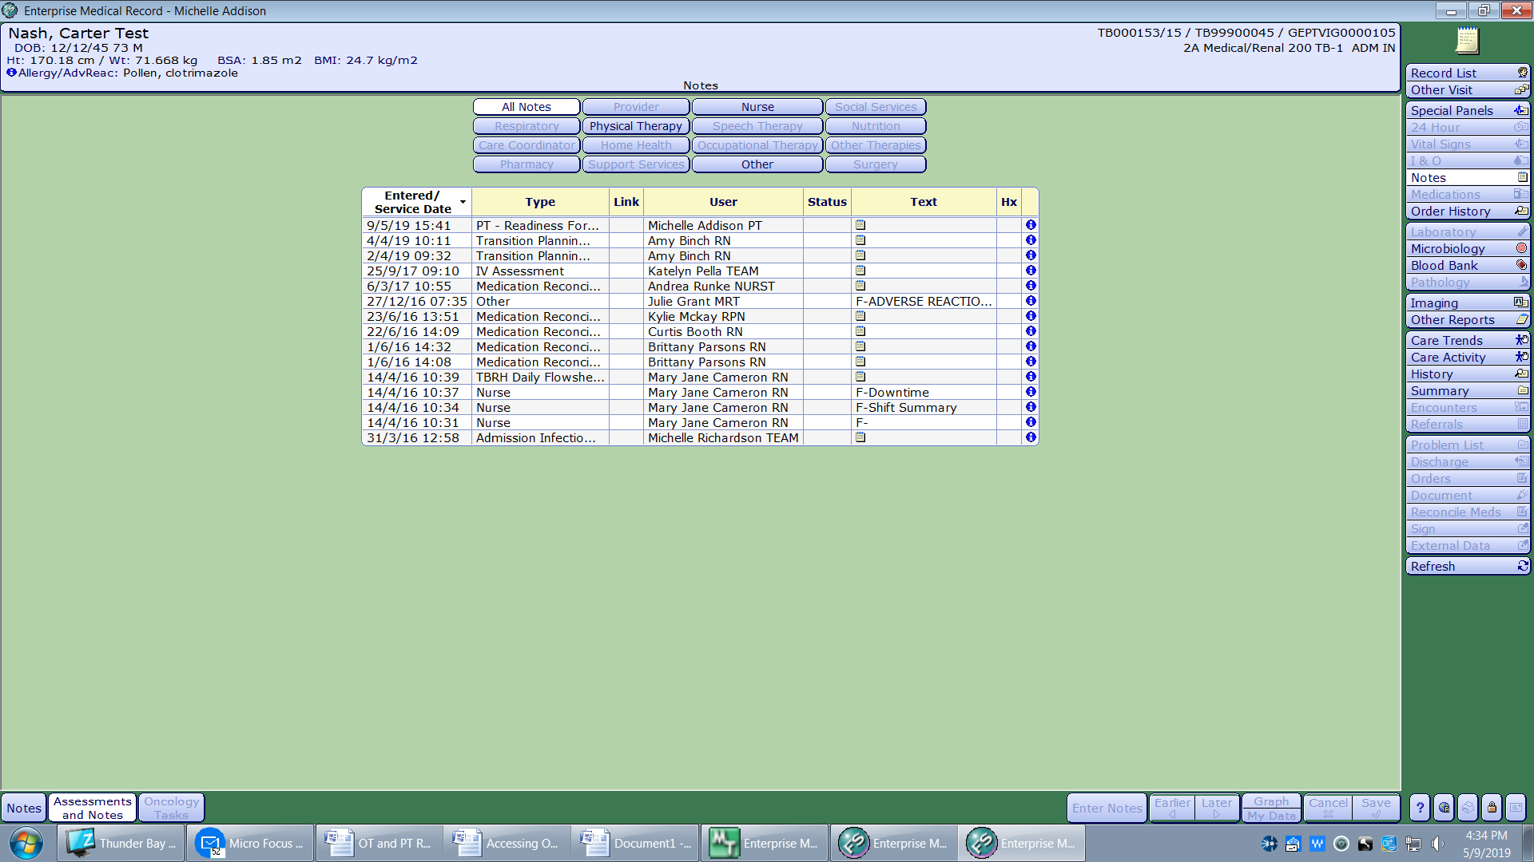

- Then search assessments/notes by Date, Intervention Type, or Provider.
Common OT Assessments include: OT – Readiness for Discharge, OT Assessment, and OT Progress Record
Common PT Assessments include: PT – Readiness for Discharge, PT Assessment and Treatment, and PT Progress Note
Common SLP Assessments include: SLP Intervention and SLP Clinical Swallow Evaluation
- Click the small blue information icon to open the assessment.
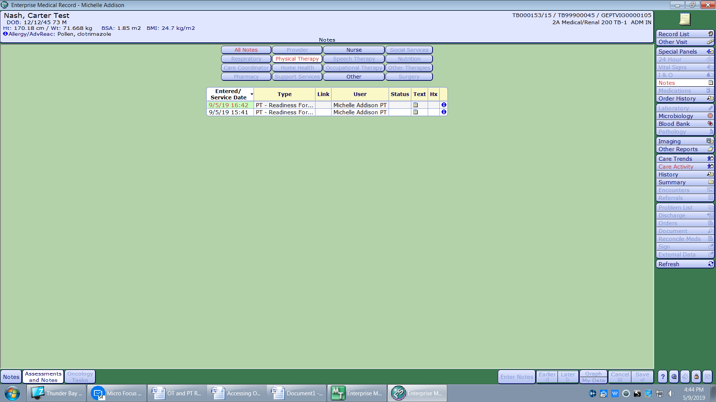
7.
6.

You will then see a screen with the assessment documentation from the team member.
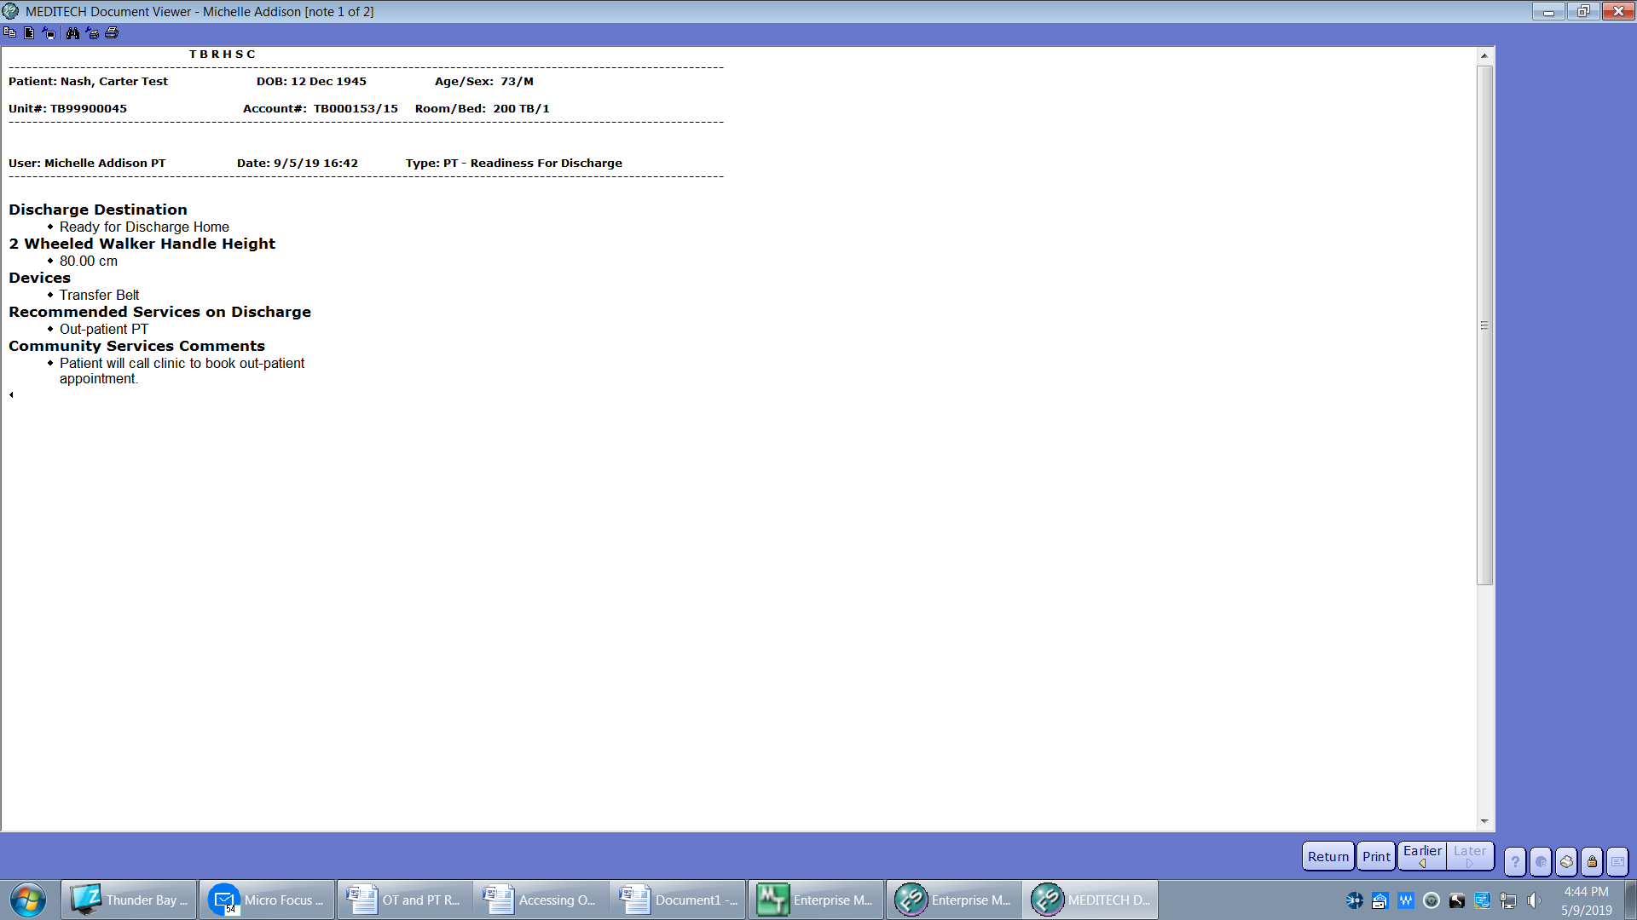

OPTION 2
- Open the EMR and choose your patient.

- Choose the current admission to access the notes for the admission, OR choose “view all visits” to see all interprofessional notes recorded in any admission.
OR

- Choose the “Care Activity” tab in the menu on the right hand side of screen
- Click on “Name” to see a list of assessments. Alternatively you can search by “Date”, showing the most recent documentation or you can search by provider if you know the name of the OT, PT or SLP, by clicking on “Recorded By”
4.
3.

- Search for the list of assessments (or provider names or dates depending on how you located the assessment) for the one you’re looking for.
Common OT Assessments include: OT – Readiness for Discharge, OT Assessment, and OT Progress Record
Common PT Assessments include: PT – Readiness for Discharge, PT Assessment and Treatment, and PT Progress Note
Common SLP Assessments include: SLP Intervention and SLP Clinical Swallow Evaluation
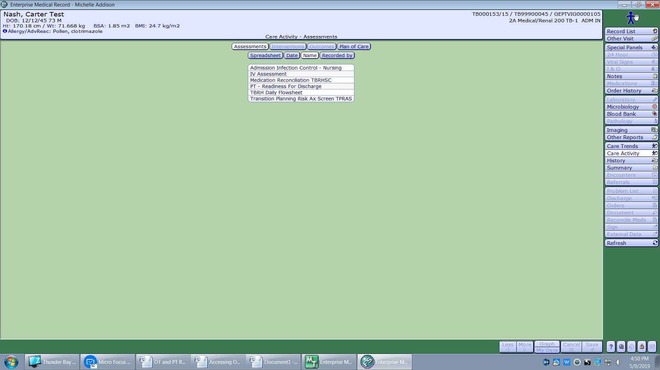
- You can then choose the assessment by clicking on the intervention name (or provider name or date depending on how you located the assessment). Click the small blue information icon to open the assessment.
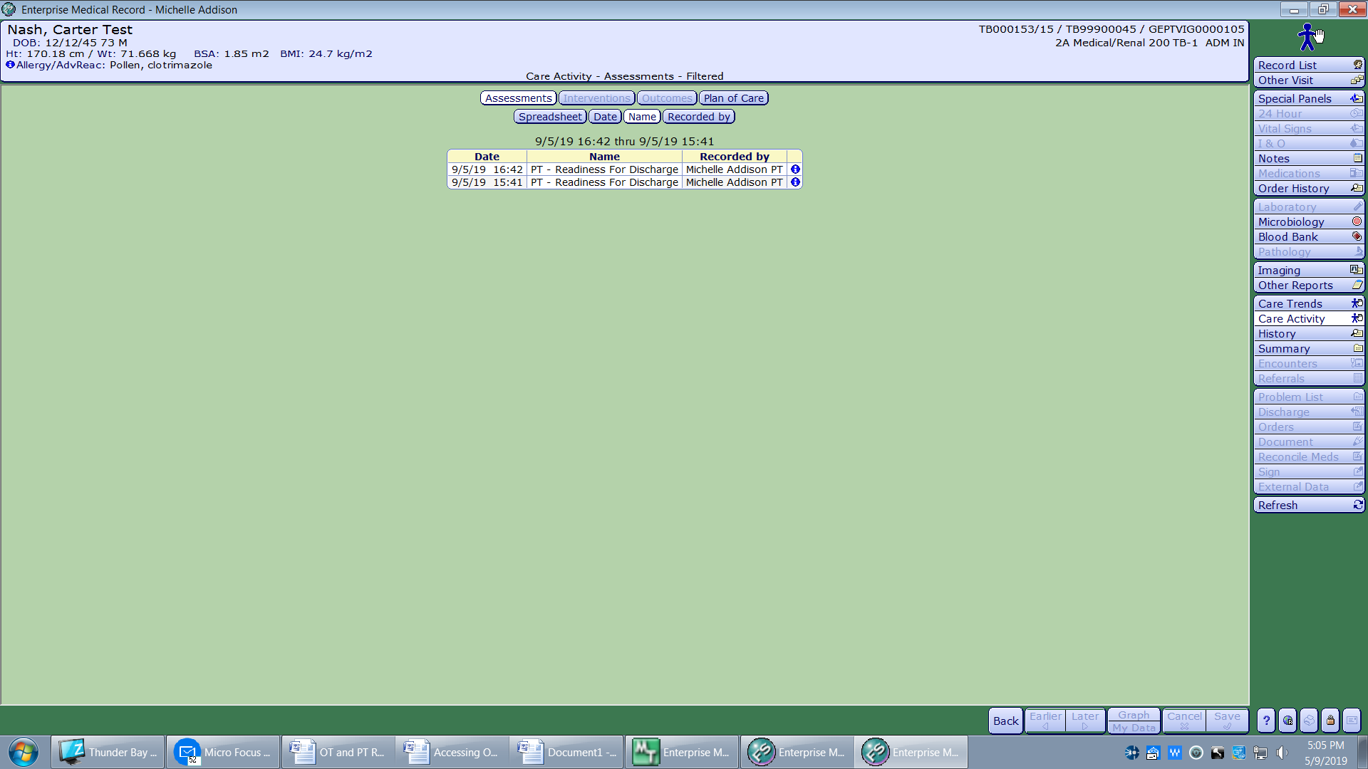

You will then see a screen with the assessment documentation from the team member.

