Baby’s First Solids
  - When should I offer solid foods? Is my baby ready? What foods do I offer and how much? Should I worry about allergens? What is baby-led weaning?

  - Due to the COVID-19 pandemic, Baby’s First Solids Classes are not running as usual, however…

  - Contact the Maternity Centre’s Registered Dietitian to find answers to these questions and more!
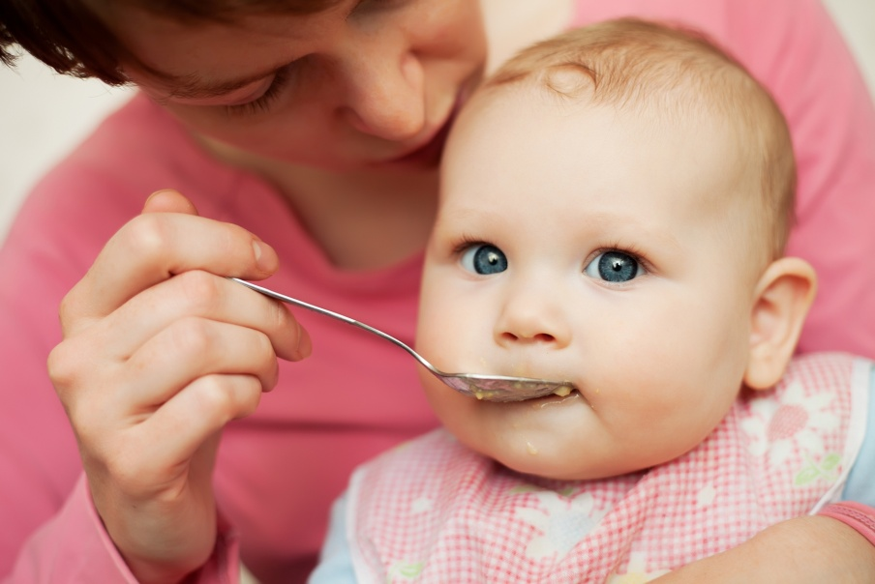

  - Email Zoe at brennerz@tbh.net to learn all about introducing solid foods to your baby!

