May 2019 Maternity Centre Bosom Buddies Group
 |  |  | 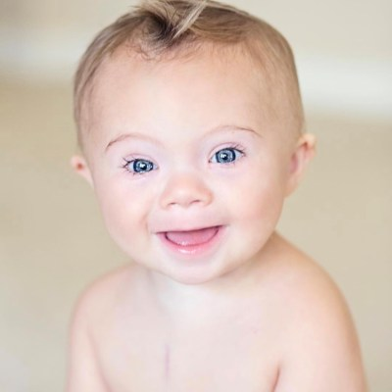
 | 06  Moms Connecting with Moms – Building Communication  Northwood Mall  2 p.m. – 3 p.m. | 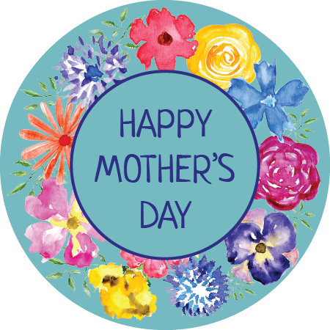 | 09
 | 13  Infant C.P.R.  St. John’s Ambulance  10am- noon or 12:30-2:30  You will need to Pre-Register  If you aren’t attending CPR come out to Hot Topics at Northwood Mall 2-3pm | 15 | 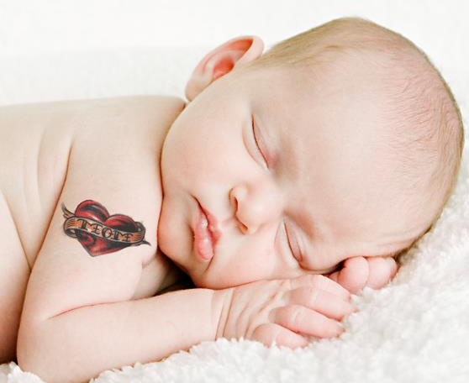
 | 21  Victoria Day  No Class Today | 24 |  | Baby Massage  11 a.m. – noon  Bring a baby blanket
28
Caring For
New Baby Teeth

Northwood Mall
2 p.m. – 3 p.m.

